ITEM | 85 - 87 Waldron Road, CHESTER HILL NSW 2162
Construction of a four (4)-storey residential flat building, consisting of eleven (11) one-bedroom dwellings and eight (8) two-bedroom dwellings over basement parking with nine (9) car parking spaces, including an outdoor communal area and associated landscaping, for use as affordable rental housing.
FILE | DA-643/2021 - Bass Hill Ward
ZONING | R4 High Density Residential
DATE OF LODGEMENT | 30 July 2021
APPLICANT | NSW Land and Housing Corporation
OWNERS | NSW Land and Housing Corporation
ESTIMATED VALUE | $7,618,056.00
AUTHOR | Planning

SUMMARY REPORT

This matter is reported to the Sydney South Planning Panel in accordance with Section 4.5(b) of the Environmental Planning & Assessment Act 1979 for regionally significant development. In accordance with State Environmental Planning Policy (State and Regional Development) 2011 Schedule 7 Clause 4 – Crown development over $5 million with NSW Land and Housing being defined as Crown through the Environmental Planning & Assessment Regulations 2000 Part 13 – Development by the Crown, Clause 226 – Prescribed persons, with a public authority (LAHC) being listed as a prescribed person.

Development Application No. DA-643/2021 proposes the construction of a four (4) storey residential flat building consisting of nineteen (19) affordable housing units (with a mix of one- and two-bedroom dwellings) with basement car parking and associated ground-level communal open space and landscaping.

The development application has been assessed in accordance with the provisions of Section 4.15(1) of the Environmental Planning and Assessment Act 1979 requiring, amongst other things, assessment against State Environmental Planning Policy (State and Regional Development) 2011, State Environmental Planning Policy No. 55 – Remediation of Land, State Environmental Planning Policy (Infrastructure) 2007, State Environmental Planning Policy (Affordable Rental Housing) 2009, State Environmental Planning Policy No. 65 – Design Quality of Residential Apartment Development, State Environmental Planning Policy (Building Sustainability Index: BASIX) 2004, State Environmental Planning Policy (Vegetation in Non-Rural areas) 2017, Bankstown Local Environmental Plan 2015, Bankstown Development Control Plan 2015 and the Draft Consolidated Canterbury Bankstown Local Environmental Plan 2020.

The proposal seeks a minor variation to the ‘landscaped area’ control contained in State Environmental Planning Policy (Affordable Rental Housing) 2009 as well as to a number of the controls contained in the Bankstown Development Control Plan 2015. The attached assessment report identifies and discusses the proposed non-compliances.

The application was advertised for a period of twenty-one (21) days from 1 September 2021 to 22 September 2021. Two (2) submissions were received which raised concerns mainly relating to traffic and density impacts on the community and overall compliance of the proposal.

POLICY IMPACT

The matter being reported has no direct policy implications.

FINANCIAL IMPACT

The matter being reported has no direct financial implications for Council.

RECOMMENDATION

It is recommended that the application be approved subject to the attached conditions.
TACHM

DA-643/2021 ASSESSMENT REPORT

SITE & LOCALITY DESCRIPTION

The subject site, comprising two (2) allotments, is formally known as Lots 66 and 67 of DP 23866, being commonly known as 85 and 87 Waldron Road, Chester Hill. Each lot is a regular, rectangular shaped allotment located on the south side of Waldron Road and are zoned R4 High Density Residential under the Bankstown Local Environmental Plan 2015. Combined, the allotments have a frontage to Waldron Road of 30.48 metres, with a site area of 1,261.6m². The allotments are generally flat, containing a slight slope from northwest to southeast with a gradient of 3.4%.

Presently the properties contain one (1) single-storey fibro dwelling house on No. 87 Waldron Road, with associated outdoor structures. No structures exist on No. 85 Waldron Road with the site having previously been cleared. The site contains seven (7) trees. One (1) power pole is located within the Council road reserve forward of the property boundary. The site is seen below in Figure 1:

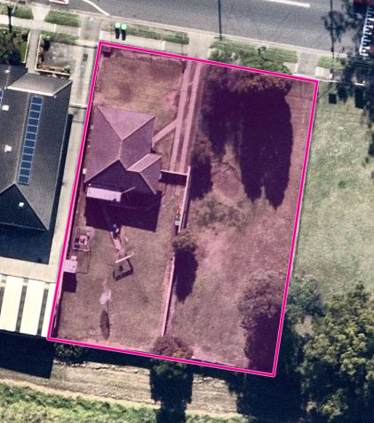
Figure 1: Subject Site

Generally surrounding the site to the north and east are allotments zoned R4 High Density Residential which currently contain a mix of single dwelling houses and dual occupancies. The site to the immediate west is zoned R4 and is occupied by the Chester Hill Neighbourhood Centre, a local community centre. Further to the west are allotments zoned B2 Local Centre, reflecting the site’s proximity to the Chester Hill Village Centre. To the south of the site is the Sydney Trains railway corridor, zoned SP2 Rail Infrastructure Facility. Across the railway corridor to the south are lots zoned R4 High Density Residential. The vicinity of the site is seen below in Figure 2:

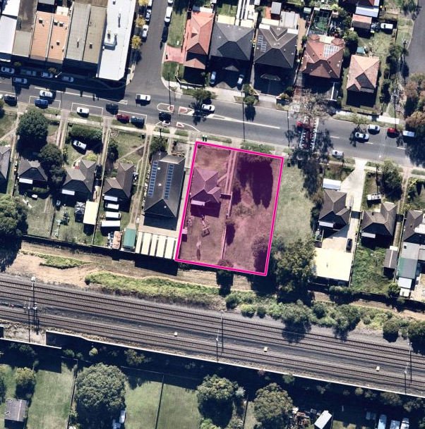
Figure 2: Site Locality

PROPOSED DEVELOPMENT

The Development Application proposes the construction of a four (4) storey residential flat building consisting of a total of nineteen (19) dwellings, comprising eleven (11) one-bedroom dwellings and eight (8) two-bedroom dwellings over basement parking with nine (9) car parking spaces with outdoor communal area and associated landscaping. The proposal, when viewed from the street frontage, is shown below in Figure 3.

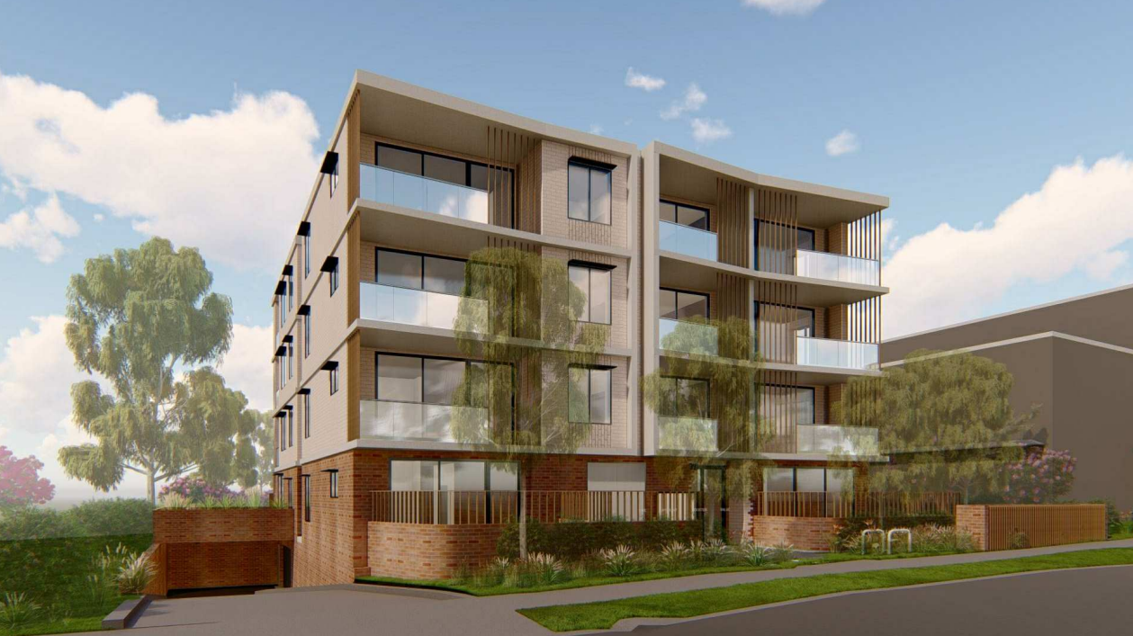
Figure 3: Proposed development

STATUTORY CONSIDERATIONS

When determining this application, the relevant matters listed in Section 4.15(1) of the Environmental Planning and Assessment Act 1979 must be considered. In this regard, the following environmental planning instruments, development control plans, codes and policies are relevant:

- State Environmental Planning Policy (Affordable Rental Housing) 2009
- State Environmental Planning Policy (Housing) 2021
- State Environmental Planning Policy (Building Sustainability Index: BASIX) 2004
- State Environmental Planning Policy (Infrastructure) 2007
- State Environmental Planning Policy No 55—Remediation of Land
- State Environmental Planning Policy No 65—Design Quality of Residential Apartment Development
- State Environmental Planning Policy (State and Regional Development) 2011
- State Environmental Planning Policy (Vegetation in Non-Rural Areas) 2017
- Sydney Regional Environmental Plan (Sydney Harbour Catchment) 2005
- Bankstown Local Environmental Plan 2015
- Draft Canterbury Bankstown Local Environmental Plan 2020
- Bankstown Development Control Plan 2015
- Bankstown Development Contributions Plan 2019

Note: On 2 December 2021, the Department of Planning and Environment announced the consolidation of SEPPs to align with 9 focus areas of the NSW planning system. This consolidation occurred on 1 March 2022 with a number of the SEPPs listed above having been consolidated into new SEPPs, though the aims, requirements and considerations have not changed. It is considered that through demonstration of compliance and consistency with the above SEPPs, compliance and consistency with the new consolidated SEPPs is achieved.

SECTION 4.15 ASSESSMENT

The proposed development has been assessed pursuant to section 4.15 of the Environmental Planning and Assessment Act, 1979.

Environmental planning instruments [section 4.15(1)(a)(i)]

State Environmental Planning Policy (State and Regional Development) 2011

According to State Environmental Planning Policy (State and Regional Development) 2011, a regional panel may exercise the consent authority functions of Council for the determination of applications included in Schedule 7. Schedule 7 includes ‘Crown Development over $5 million’. The applicant, Land and Housing Corporation, is a Crown Authority and the proposed development has a capital investment value of $ 7,618,056.00. Accordingly, the application is reported to the Sydney South Planning Panel for determination.

State Environmental Planning Policy (Affordable Rental Housing) 2009

The following clauses of State Environmental Planning Policy (Affordable Rental Housing) 2009 were taken into consideration:

Division 1 In-Fill Affordable Housing
Standard | Requirement | Proposal | Compliance
10 Development to which Division applies | Applies to permitted development in an accessible area with at least 20% affordable housing | The development is permitted with consent under BLEP 2015 and comprises a GFA of in excess of 20% affordable housing, being 100% affordable while being located in an accessible area within the Greater Sydney Region being 433 metres walking distance from Chester Hill Railway Station. | Y
13  Floor space ratios | Floor space bonus | Existing permissible FSR is 1:1 under BLEP 2015. 100% of the development is for the purpose of affordable housing, allowing for a 0.5:1 bonus.  1.5:1 FSR is permitted  1.1:1 FSR proposed | Y
14 Standards that cannot be used to refuse consent | 1 – Site and solar access requirements  - Minimum site area  - Landscaped area is at least 35 square metres of landscaped area per dwelling  - Deep soil zones minimum  - Solar access minimum  2 – General  - Parking minimums  - Dwelling size minimums based on number of bedrooms | 1 – Site and solar access requirements  - Y - Site area is in excess of 450m² being 1,261.6m².  - N - 457.4m² of landscaped area is provided while 665.0m² is required (deficit of 207.6m²)  - Y - 244.6m² / 1261.6m² = 19% deep soil with 2/3rds of deep soil located at the rear  - Y - 14 / 19 = 73% of the units satisfy the solar access provisions  2 – General  - 11 x 1-bedroom = 4.4 spaces and 8 x 2-bedrooms = 4 spaces. 8.4 spaces required.  9 spaces provided  - All apartments comply with the minimum sizes | N  Discussion below
16A Character of local area | Consideration of compatibility of development with character of local area | The proposed development is consistent with the expected character of the area which is transitioning from low-density residential to high-density residential and mixed-use developments. | Y
17  Must be used for affordable housing for 10 years | Not applicable for land owned by Land and Housing Corporation | The subject application has been submitted to Council by NSW Land and Housing | Y

14 Standards that cannot be used to refuse consent
An assessment of the Development Application revealed that the proposal complies with the matters raised in each of the above clauses of SEPP (Affordable Rental Housing) 2009 except for Clause 14(1)(c) with regard to the provision of 35m² of landscaped area per dwelling. With 19 dwellings, a total landscaped area of 665m² would be required, whereas an area of 457.4m² is proposed through this development, representing a 31% shortfall. It is considered that the non-compliance is worthy of support due to the high-density nature of the development, and achievement of 30% landscaped site area, which would be required for non-social housing providers with the site comprising 36% landscaped area. Compliance with this control is considered to be unsuitable for high-density in-fill affordable housing developments such as the proposed, as the amount of landscaped area required would result in a reduction of six (6) housing units, representing a 32% reduction in the size of a development which otherwise achieves compliance with height and floor space ratio controls.

Further, the proposed open spaces provide for a desirable planning outcome as the setbacks proposed are double the required 3-metre setbacks, and the open space allows for a variety of passive and active recreational areas and complies with the NSW Apartment Design Guide.

State Environmental Planning Policy (Housing) 2021

Pursuant to section 4.15(1)(a)(i) of the EPA Act 1979, consent authorities are required to take into consideration the provisions of SEPP (Housing) 2021 when assessing development applications for various types of housing typologies. The instrument came into force on 26 November 2021 and includes a savings provision whereby applications lodged prior to the commencement of the instrument are required to consider the SEPP but would not be bound by it (continuing to have the same authority as a proposed instrument).

The instrument makes several changes to a variety of types of residential accommodation, including in-fill affordable housing. The table below outlines this application’s compliance with the relevant changes to the specified development typology:

Division 1 In-Fill Affordable Housing
Standard | Change | Proposal | Compliance
16 Development to which Division applies (formerly 10 Development to which Division applies) | Change to remove item (b) regarding applications on land containing a heritage item. | The subject site does not contain a heritage item and is not impacted by the change. | Y
17 Floor space ratio (formerly 13 Floor space ratio) | Changes to calculation of bonus FSR for sites with an existing FSR in excess of 2.5:1, as well as clarification that the bonus is to be used for affordable housing purposes | The subject site has an existing FSR of less than 2.5:1 and so is not impacted by changes to the bonus calculation. All of the development’s GFA is proposed to be used as affordable housing. | Y
18 Non-discretionary development standards—the Act, s 4.15 (formerly 14 Standards that cannot be used to refuse consent) | Dwelling size minimums shift from areas noted under ARH SEPP to the Apartment Design Guide | Minimum dwelling sizes comply with ADG requirements | Y
Repealed (formerly 16A Character of local area) | Removal of requirement for consent authority to consider compatibility with character of local area. | N/A | N/A
21 Must be used for affordable housing for at least 15 years (formerly 17 Must be used for affordable housing for 10 years) | Change in affordable housing duration from 10 to 15 years. | Subject development is to be run by a social housing provider, which results in the duration requirement not being applicable. | N/A
Addition of 18 Subdivision | Land of the development may be subdivided | No subdivision is proposed | N/A

The subject application is consistent with the abovementioned principals and provisions of SEPP (Housing) 2021.

State Environmental Planning Policy (Building Sustainability Index: BASIX) 2004

In accordance with SEPP (BASIX), a BASIX Certificate accompanies this application. The Certificate makes a number of energy/resource commitments relating to water, energy and thermal comfort. The relevant commitments indicated on the BASIX Certificate have been shown on the plans in order to satisfy objectives of the SEPP. The BASIX Certificate requirements have been incorporated into conditions of consent.

State Environmental Planning Policy (Infrastructure) 2007

Given its location adjoining the Sydney Trains railway corridor, the application requires consideration of State Environmental Planning Policy (Infrastructure) 2007 (ISEPP 2007), Division 15 Railways, Clauses 85, 86 and 87.

The application was referred to Transport for New South Wales (Sydney Trains), pursuant to Clauses 85 and 86 of the ISEPP 2007. Sydney Trains have provided concurrence subject to the imposition of conditions to be satisfied prior to works commencing and during the construction phase. As such, it is considered that the requirements of Clause 85, 86 and 87 are satisfied, subject to the recommended conditions of consent.

State Environmental Planning Policy No 55—Remediation of Land

Clause 7 of SEPP 55 – Remediation of Land requires Council to consider whether the land is contaminated prior to granting consent to the carrying out of any development on that land. Should the land be contaminated, the consent authority must be satisfied that the land is suitable in a contaminated state for the proposed use. If the land requires remediation to be undertaken to make it suitable for the proposed use, the consent authority must be satisfied that the land will be remediated before the land is used for that purpose.

The site has a continuous history of residential use, dating back to 1951, and Council has no record of either allotment having been subject to a potential source of contamination. Council officers have reviewed the proposal and are satisfied that the site is suitable for the proposed ongoing residential use, subject to recommended conditions. It is therefore considered that the consent authority can be satisfied that the development site is suitable for the proposed development, in accordance with Clause 7 of SEPP 55.

State Environmental Planning Policy No 65—Design Quality of Residential Apartment Development (2002)

This policy applies to residential apartment development and is required to be considered when assessing this application. Residential apartment development is defined under SEPP 65 as development for the purpose of a residential flat building, shop top housing or mixed-use development with a residential accommodation component. The development must consist of the erection of a new building, the conversion of an existing building or the substantial redevelopment or refurbishment of an existing building. The building must also be at least 3 or more storeys and contain at least 4 or more dwellings, with this development being 4 storeys.

SEPP 65 aims to improve the design quality of residential apartment development across NSW and provides an assessment framework, the Apartment Design Guide (ADG), for assessing ‘good design’. Clause 50(1A) of the Environmental Planning and Assessment Regulation 2000 requires the submission of a design verification statement from a qualified designer (registered architect) at lodgement of the development application that addresses the design quality principles contained in SEPP 65 and demonstrates how the objectives in Parts 3 and 4 of the ADG have been achieved.

The proposal has been considered against the various provisions of the ADG in accordance with Clause 28 (2)(c) of SEPP 65. The development is consistent with the objectives and Design Quality Principles contained in SEPP 65 and ADG and responds appropriately to the site’s context. Moreover, the application generally conforms with the key ‘design criteria’ contained in the Apartment Design Guide, as illustrated through the submitted Design Verification Statement and the table below.

State Environmental Planning Policy 65 – Design Quality of Residential Apartment Development
Criteria | Requirement | Provided | Complies
Part 3 Siting the Development
3D-1 Communal and Public Open Space | Minimum open space area is equal to 25% of the site area.  50% direct sunlight to principal usable part of open space for 2 hours between 9am and 3pm on June 21. | Principal communal open space area is located at the south-western corner of the site, which is considered to be a suitable location with regards to long-term solar access. Additional areas within the southern and western setbacks complement this space and provide for a range of activity opportunities.  377.2m² of open space for a site area of 1261.6m² = 30% communal open space.  Open space achieves compliant solar access with in excess of 200m² of area located at the south-west quadrant of the site achieving two hours access at the June solstice. | Y
3E-1 Deep Soil Zones |  | 245m² / 1261m² = 19% of the site is dedicated as deep soil achieving a minimum dimension of 3 metres throughout. | Y
  Site Area | Minimum Dimension | Deep Soil %
  650m² – 1,500m² | 3m | 7%
3F-1 Visual Privacy |  | Building is provided with adequate setbacks of 6 metres to habitable rooms. | Y
  Building Height | Habitable Rooms and Balconies | Non-habitable Rooms
  Up to 12m | 6m | 3m
  Up to 25m | 9m | 4.5m
3J-1 Bicycle and Car Parking | Car parking is provided based on proximity to public transport in Metropolitan Sydney and centres in regional areas. | Parking provided complies with SEPP ARH.  Guide to Traffic Generating Development: Defined as a medium-density RFB requires 1 space per unit plus an additional 1 space per 5 2-bedroom units, as well as 1 space per 5 units for a visitor space. With 19 units this requires (19 + 2 + 4) 25 car parking spaces.  Nine (9) car parking spaces are provided. SEPP ARH requires 8 spaces, which is a standard that cannot be used to refuse consent and as such, nine (9) spaces is suitable. | Y
PART 4 – DESIGNING THE BUILDING
4A-1 Solar and Daylight Access | At least 70% of apartments in a building receive a minimum of 2 hours direct sunlight between 9 am and 3 pm at mid-winter.  A maximum of 15% of apartments in a building receive no direct sunlight. | All units achieve two-hour solar access minimums per the ADG and comply with the minimum 3-hours access per SEPP ARH.  No apartments receive no solar access. | Y
4B-3 Natural Ventilation | At least 60% of apartments are naturally cross ventilated. | Natural cross-ventilation is considered suitable with 84% compliance (16 of 19 units). | Y
4C-1 Ceiling Heights |  | Ceiling heights are suitable for habitable and non-habitable rooms, with a minimum of 3.0 metres provided. | Y
  Habitable Room | 2.7m
  Non-habitable | 2.4m
4D-1 Apartment Size and Layout |  | All units comply with the minimum area requirements for 1-bedroom and 2-bedroom dwellings. | Y
  Studio | 35m²
  1-bed | 50m²
  2-bed | 70m²
4D-2 Apartment Size and Layout | Habitable room depths are limited to a maximum of 2.5 x the ceiling height  The maximum habitable room depth is 8m from a window | All units comply with the minimum area requirements for 1-bedroom and 2-bedroom dwellings.  No dwellings exceed an 8-metre room depth. | Y
4D-3 Apartment Size and Layout | Master bedrooms have a minimum area of 10m² and other bedrooms 9m²  Bedrooms have a minimum dimension of 3m  Living rooms or combined living/dining rooms have a minimum width of:  - 3.6m for studio and 1-bedroom apartments  - 4m for 2-bedroom and 3-bedroom apartments | All bedrooms comply with minimum dimensions and areas.  All living rooms comply with minimum dimension based on number of bedrooms. | Y
4E-1 Private Open Space and Balconies |  | All units comply with minimum areas required and with minimum depths for ground floor and upper-floor balconies. | Y
  Studio | 4m² | -
  1-bed | 8m² | 2m
  2-bed | 10m² | 2m
  3-bed | 12m² | 2.4m
  Ground level private open space must have a minimum area of 15m² and a minimum depth of 3m
4F-1 Common Circulation and Spaces | The maximum number of apartments off a circulation core on a single level is eight.  For buildings of 10 storeys and over, the maximum number of apartments sharing a single lift is 40 | Common circulation provided is legible and satisfactorily dimensioned.  Maximum of 5 units access per floor from single lift. | Y
4G-1 Storage |  | Storage plan provided and demonstrates compliance – kitchen areas have been excluded from calculations. | Y
  Studio | 4m³
  1-bed | 6m³
  2-bed | 8m³
  3-bed | 10m³
4O-1 Landscape Design | Landscape design is viable and sustainable | Provides for a range of planting areas and specimens for large trees and shrubbery. | Y

The subject application complies with the relevant provisions of the Apartment Design Guide.

State Environmental Planning Policy (Vegetation in Non-Rural Areas) 2017

The proposed development seeks approval for the removal of seven (7) trees. Council’s Tree Management Officer has reviewed the application and raised no objection to the removal of the trees on site, subject to replacement tree plantings and the tree protection measures recommended. Conditions of consent have been imposed to achieve this requirement. It is considered that the proposal meets the requirements of Clause 7, 9 and 10 of the SEPP.

Sydney Regional Environmental Plan (Sydney Harbour Catchment) 2005

The subject site is located within the plan area for the Sydney Harbour Catchment, with the proposed development considered to comply with the objectives of Part 2 and being considered to satisfy the matters for consideration contained within Division 2 of the instrument. It is considered that the development remains consistent with the aims of the Plan, with regard to the protection of Sydney Harbour.

Bankstown Local Environmental Plan 2015

An assessment of the Development Application revealed that the proposal complies with the matters raised in each of the following relevant clauses of BLEP 2015.

- Cl. 1.2 Aims of Plan
- Cl. 2.2 Zoning of land to which Plan applies - Land Zoning Map
- Cl. 2.3 Zone objectives and Land Use Table
- Cl. 4.1B Minimum lot sizes and special provisions for certain dwellings
- Cl. 4.3 Height of buildings - Height of Buildings Map
- Cl. 4.4 Floor space ratio - Floor Space Ratio Map
- Cl. 5.21 Flood Planning

The proposal complies with all relevant aims, objectives, controls and standards of the Bankstown Local Environmental Plan 2015.

Draft environmental planning instruments [section 4.15(1)(a)(ii)]

Draft Canterbury Bankstown Local Environmental Plan 2020

The Draft Canterbury Bankstown Local Environmental Plan 2020 (CBLEP 2020) applies to the subject site. The Draft CBLEP 2020 has been publicly exhibited and was adopted by the Canterbury Bankstown Local Planning Panel on 30 June 2020. While the draft instrument proposes the introduction of some additional provisions, in the most part, the Draft CBLEP 2020 provides for an administrative conversion of both the BLEP 2015 and CLEP 2012 into a combined document under the Standard Instrument LEP template.

With respect to the proposed development, the proposal is considered to be consistent with the aims, the controls and the standards of the draft instrument (being identical to the provisions contained in the current applicable local environmental plan).

Development control plans [section 4.15(1)(a)(iii)]

Bankstown Development Control Plan 2015

The following provides a summary of the development application against the controls contained in Parts A1, B1 and B5 of Bankstown Development Control Plan 2015.

Part A1 of BDCP 2015

The Chester Hill Village Centre and Sefton Small Village Centre are connected by Waldron Road and the railway line. These two precincts complement and support each other in their role as a village centre and a small village centre for the North West Local Area. Figure 4 below outlines the desired structure plan with a retail core along Waldron Road and a surrounding residential transitional area.

The subject site is shown as being located within the residential area of transition. The development is consistent in achieving the objectives of the control as it provides for a redevelopment and increase in housing stock. Section A1 contains controls for development, typically applying to only the business zone, however Clause 2.5 of Section 4 of Part A1 applies to this site and has been assessed below.

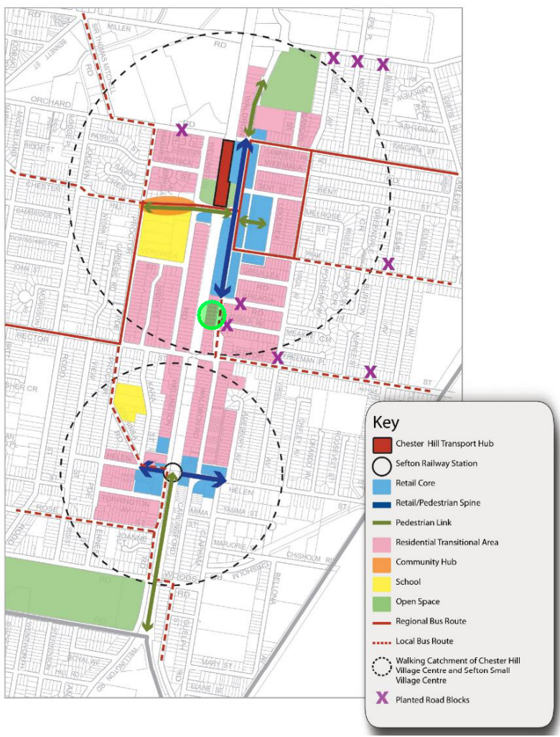
Figure 4: BDCP 2015 Map Excerpt
Site shown circled in green

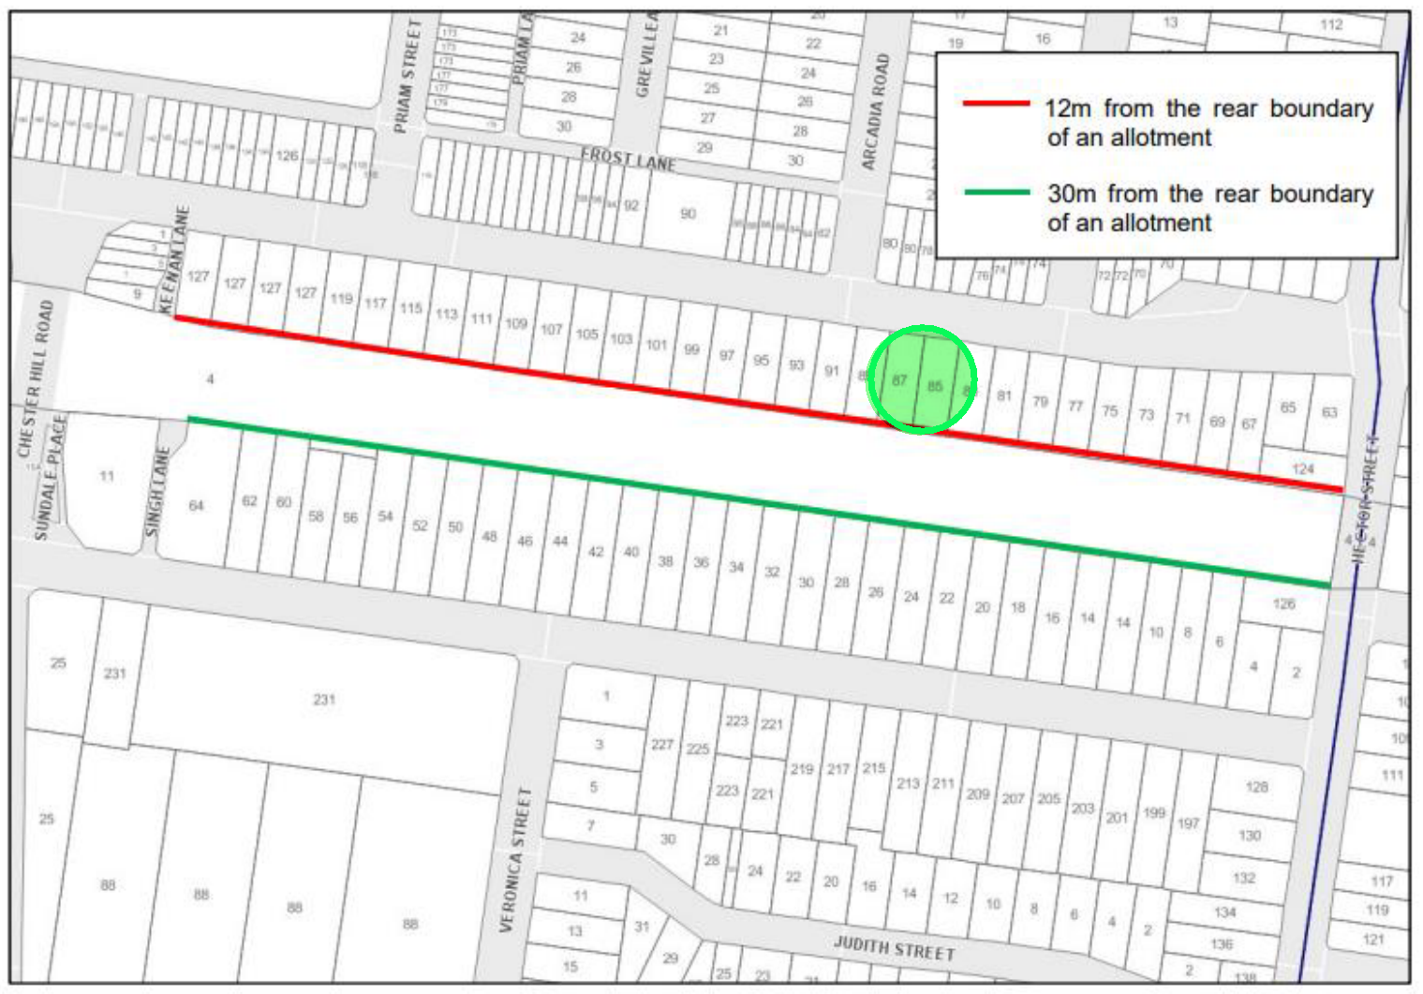
Figure 5: BDCP map excerpt
Site shown circled in green

Bankstown Development Control Plan 2015 Part A1 Section 4 Chester Hill Village Centre and Sefton Small Village Centre
Clause | Requirement | Comment | Complies
2.5 Setbacks to the rear boundary of allotments | Despite clause 2.4, dwellings on allotments identified in Figure 5 (above) must comply with:  - the minimum setbacks shown in Figure 5; or  - incorporate appropriate measures to ensure that the following LAeq levels are not exceeded:  - in any bedroom in the building–35 dB(A) at any time between 10.00 pm and 7.00 am; and  - anywhere else in the building (other than a garage, kitchen, bathroom or hallway)–40 dB(A) at any time. | The application has been accompanied by an acoustic report. The acoustic report has been reviewed by Council’s Health officers and it is considered that, subject to conditions, the proposal can achieve satisfactory acoustic amenity for the residents. | Y

Bankstown Development Control Plan 2015 Part B1 Section 9 Residential Flat Buildings
Clause | Requirement | Comment | Complies
9.1 Isolation of allotments | In R4 maintain 1,200m² with a width of 20 metres | The development will not isolate adjoining properties | Y
9.2 Storey limit |  | 13 metre building height per BLEP 2015 allows for 4 storeys, with 4 storeys proposed. | Y
  BLEP Height | Storey Limit
  13 | 4
9.3 Storey limit | Must be compatible with the existing slope and contours of the allotment and any adjoining property. | Development is compatible with the gentle slope of the land, from northwest to southeast. | y
9.4 Storey limit | Reconstituted ground level on the allotment must not exceed a height of 600mm above NGL of an adjoining property. | No proposed retaining walls higher than existing NGL. | Y
9.5 Primary and secondary setback restrictions | 6 metre primary road setback. | 6.0 metre front setback (except for balcony articulation which is considered suitable in this instance). | Y
9.10 Setbacks to side and rear boundaries | Minimum 2 metre basement setback to side and rear boundaries. | Minimum 6.0 metre side and rear basement setback. | Y
9.11 Setbacks to side and rear boundaries | Minimum 1 metre driveway side setback. | 1.0 metre setback between the driveway edge and property boundary at ground level. | Y
9.12 Private open space | Private open space is to behind the front building line (not applicable to balconies for articulation). | Private open spaces are located within the front building setback, in additional to balcony protrusions. | N  discussion below
9.13 Building design | SEPP 65 applies. | Considered within this report. | Y
9.15 Building design | 10 or more homes must provide 1 adaptable unit per 50 dwellings | 2 adaptable dwellings provided. | Y
9.16 and 9.20 Building design | 35-degree maximum roof pitch. Roof-top balconies not permitted | Flat roof proposed, with no balconies. | Y
9.21 Building Design | Plant room and services must be integrated within the architecture and be screened from view from the street and adjoining properties | Plant rooms and services are proposed to be integrated within the design of the development. | Y
9.22 Building design (car parking) | Parking is to be behind the front building line | All parking is located behind the front building setback. | Y
9.23 – 9.27 Building Design (substations, utilities and building services | Substations, utilities and building services are to be integrated into the building design and concealed from public view. | No substation proposed.  Services and utilities are incorporated into the design of the proposal. | Y
9.28 – 9.29 Landscaping | Retain and protect significant trees. | Tree removal considered suitable via condition of consent.  55% landscaped front setback. Provisions for multiple tree plantings. | Y
9.30 Security | Boundary with a railway corridor or an open stormwater drain, setback a minimum 1.5 metres from that boundary. | The proposal complies with regard to the railway corridor interface. Further, a TfNSW referral provided concurrence that the proposal is satisfactory with the requirements of the rail authority. | Y

Bankstown Development Control Plan 2015 Part B5 Parking
Clause | Requirement | Comment | Complies
2.1 | Parking Rate for RFB:  In Zone R4, Zone B1, Zone B2 and Zone B6  - 1 car space per 1-bedroom dwelling; or  - 1.2 car spaces per 2-bedroom dwelling; or  - 1.5 car spaces per 3 or more-bedroom dwelling; and  - 1 visitor car space per 5 dwellings. | This requires 25 spaces.  SEPP ARH requires 8 spaces | N/A

As noted in the table above, the development fails to comply with Clause 2.5 of Part A1 with regard to setbacks from a rail corridor and Clauses 9.11 and 9.12 of Part B1 with regard to setbacks and private open space. A discussion of these non-compliances follows:

Part A1 Section 4 Clause 2.5 – Requires a 12-metre setback to the rail corridor. The proposal has been supplied with an acoustic report to demonstrate than an 11.5 metre setback to the railway corridor maintains adequate internal amenity with regard to noise and vibration for future occupants. This is considered to result in a reasonable planning outcome and would remain consistent with other approvals within the area, notably DA-861/2020 at Nos. 48-50 Wellington Road, Chester Hill.

Part B1 Section 9 Clause 9.12 – Requires private open spaces to be behind the front building line. The proposal includes two ground-floor private open spaces located within the front setback. This is consistent with the design criteria of the NSW Apartment Design Guide, which encourages an appropriate transition between the private and public domains and positive interactions between the development and the street frontage. This proposal is consistent with other approvals provided for within the LGA and is considered to be an acceptable planning outcome.

Planning agreements [section 4.15(1)(a)(iiia)]

No planning agreement has been entered into.

The regulations [section 4.15(1)(a)(iv)]

The development is consistent with the provisions contained within the Environmental Planning and Assessment Regulation 2000.

The likely impacts of the development [section 4.15(1)(b)]

The proposed development is not considered likely to result in any significant detrimental environmental, social or economic impacts on the locality. As detailed in this report, where non-compliances with the relevant SEPP ARH and BDCP 2015 controls occur, they have been addressed and are considered worthy of support. As such, it is considered that the impact of the proposed development on the locality would be acceptable.

Suitability of the site [section 4.15(1)(c)]

The site is considered suitable for the development.

Submissions [section 4.15(1)(d)]

The application was advertised in accordance with the Canterbury Bankstown Community Participation Plan 2019 for a period of 21 days ending on 22 September 2021. Two (2) unique submissions objecting to the proposal were received by Council. Responses to the submissions lodged are provided below.

Issue: Overlooking / Visual Privacy
Response: The proposal has been designed to comply with visual privacy requirements of the NSW Apartment Design Guide as well as with the requirements of the Bankstown Development Control Plan 2015, with regard to setbacks to side and rear boundaries and the restriction of direct overlooking into living areas and private open spaces on adjoining properties.

Issue: Increase in Vehicle Traffic
Response: A traffic and parking report was submitted with the proposal, which was reviewed and found to be satisfactory by Council’s Traffic Department with regard to a potential increase in vehicle movements within the area. The area is provided with suitable street network capacity for the scale of the development.

Issue: Traffic Safety Impacts
Response: The application has been reviewed by Council’s Traffic Department and Development Engineers with regard to the proposed ingress and egress of vehicles to / from the site as well as pedestrian safety at the property frontage along the footpath. The development was found to comply with relevant Australian Standards and is not considered to result in significant impacts in regard to traffic safety.

Issue: Neighbourhood Overcrowding / Capacity of Services
Response: The proposal is not likely to bring about undue impacts on the local services available within the vicinity, with the site being zoned for R4 High Density residential developments and the development being limited to one and two-bedroom dwellings.

Issue: Compliance with Planning Controls
Response: The proposal has been assessed as compliant with all relevant planning controls, except for minor non-compliances to landscaped areas and open space setbacks, both of which are considered to be worthy of support in this instance and are not considered likely to result in adverse impacts on the locality as discussed within this report.

Issue: Increase in Noise and Dust
Response: Conditions of consent have been imposed to manage the construction related activities for the development. Demolition has not been consented to through this determination and requires separate authorisation.

Issue: Generation of Social and Community Issues / Anti-Social Behaviour
Response: No evidence to support a rise in anti-social behaviour from a social housing development was submitted for assessment. The development has been designed in accordance with the NSW Apartment Design Guide with regard to passive streetscape surveillance and positive interactions between the development and the public domain.

Issue: On-Street Car Parking
Response: The proposal will retain existing on-street car parking (subject to changes for waste collection), which is available on a first-in best-dressed manner. Basement parking is provided on site exceeds the minimum number required by State Environmental Planning Policy (Affordable Rental Housing) 2009.

Issue: Heavy Vehicle Movements
Response: Heavy vehicle movements in and around the site can be anticipated during works to the site and are to be adequately managed to minimise potential impacts on the locality.

The public interest [section 4.15(1)(e)]

Approval of the development would be consistent with the wider public interest.

CONCLUSION

The Development Application has been assessed in accordance with the matters for consideration contained in Section 4.15 of the Environmental Planning and Assessment Act 1979, which required, amongst other things, an assessment against the provisions contained within State Environmental Planning Policy (State and Regional Development) 2011, State Environmental Planning Policy No. 55 – Remediation of Land, State Environmental Planning Policy (Infrastructure) 2007, State Environmental Planning Policy (Affordable Rental Housing) 2009, State Environmental Planning Policy No. 65 – Design Quality of Residential Apartment Development, State Environmental Planning Policy (Building Sustainability Index: BASIX) 2004, State Environmental Planning Policy (Vegetation in Non-Rural areas) 2017, Bankstown Local Environmental Plan 2015, Bankstown Development Control Plan 2015 and the Draft Consolidated Canterbury Bankstown Local Environmental Plan 2020.

The proposal seeks consent for a four (4) storey residential flat building development and proposes some minor variations to the applicable controls contained in Part B1 of Bankstown Development Control Plan 2015. The variation to SEPP (Affordable Rental Housing) is considered worthy of support as the development includes generously-sized and well-designed landscaped areas which provide a variety of spaces for residents to enjoy and which are in keeping with the requirements of the NSW Apartment Design Guide.

Despite the non-compliances proposed with the application, it is considered that the development application is an appropriate outcome in the context of the surrounding locality and has been recommended for approval, subject to the draft conditions attached to this report.

RECOMMENDATION

It is recommended that the application be approved subject to the attached conditions.

